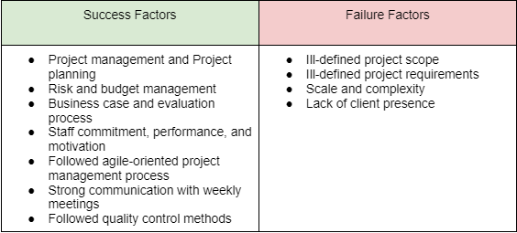

This project presented several challenges for our team, primarily during the requirements gathering and research stage. We had a difficult time understanding the requirements and scope of the project during the earlier client meetings. This was eventually resolved once our client allowed us to speak to someone higher up in the business who had a better understanding of what they were after.

The size and complexity of the project were quite time-consuming. A lot of research had to be conducted to determine which external services best suited the needs of the journey planner. There is a tonne of hosting platforms, direction APIs and mapping solutions out there that all have different pros and cons, we were able to narrow down our options eventually, and we ended up with a robust suite of tools that proved to be highly reliable and easy to work with. Another difficulty we encountered with the scale and deadlines of the project was staff allocation. It would be beneficial to use as many of our staff as possible to complete the journey planner within the specified time frame. This meant that we had to spend a lot of time analysing the skills of each staff member so we could be positive that the tasks being assigned to them were going to be completed on time.

The management of the project couldn’t have been better. Solid plans were laid out from start to finish. Risks were considered throughout the process, and our budget was kept in mind during financial decisions. Our methodology proved to help staff performance, and our weekly meetings flowed well. The quality control methods we implemented throughout the development process ensured the final product was of the highest quality.

Overall, the project ran very smoothly, and we eventually overcame all the challenges we encountered. Due to this, we consider the Journey Planner project a success.